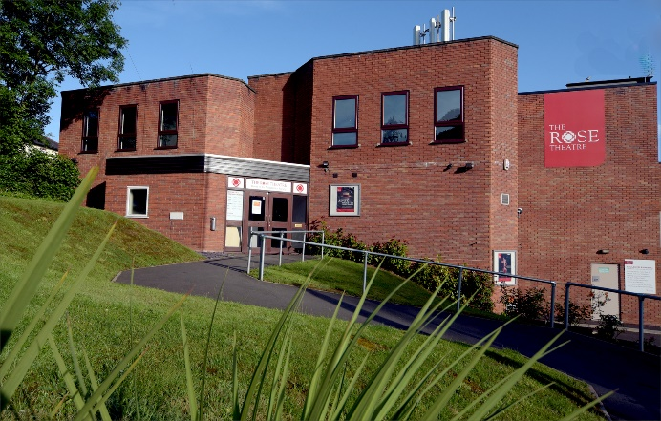

DECEMBER 2018
Greetings from the Chairman
As this year draws to a close, it is my pleasure, as the new Chairman of the Nonentities, to write the introduction to final newsletter of 2018. It has been a year of change, not least because there is a new Committee in place, and it is a new person writing this piece & one of my first honours is to express the society’s gratitude to my predecessor, Stephen Downing, for his hard work & commitment over the past six years.
New members have joined our ranks this year and have served the society with distinction, whilst we have mourned the passing of some of the most influential figures in the history of the Nonentities’, with the passing of Hugh Meredith, Bob Garner, John Hunter and Dennis White. We have also had our celebrations, too, not least of which was Andy & Faye’s fantastic wedding.
This year has seen both successes and challenges. Later in the newsletter, our returning Artistic Director, Jen, shares some of our on-stage achievements, but off stage we have had successes too. A fabulous new air conditioning/heating system and a new roof over bar are just two, but these mean we now have challenges as we must repair the bar ceiling, decommission the downstairs boiler and install independent heating in the dressing room areas. Costly, but necessary, improvements, so financial success remains very important to us going forward to 2019. Other challenges emerged as we engaged in several external projects which were marvellous for our profile in the area, but which put a strain on our resources. However, Christmas is a time to celebrate and we should enjoy their success.
I am not one for singling people out, but this year I think we should offer special thanks to the public face of our organisation, Gary and Natalie, for all their hard work and dedication. I cannot possibly thank every member individually for their contributions this year, but I hope you will all accept the gratitude of the Committee for all of your efforts and commitment this year and I hope The Nonentities’ can continue to rely on your support in the future.
Merry Christmas and a Happy New Year to you all,
Bob

ARTISTIC DIRECTOR’S STUFF!

We have had a very busy few weeks! Thank you for your support in my new role.

As far as the general public is concerned, we have had great successes this Autumn. Since the AGM our calendar has been very full. We had just completed All Shook up, were about to go into The Mikado, followed by Thrill of Love, Garland of Poppies, Armistice Day celebrations, Suffragettes, The Witches, Christmas Entertainment & Peter Pan: all in 8 weeks. I know some of these were external productions, but we still needed to find staff, and at a very busy time of year. Our membership has been heavily strained, and we have had a great deal of difficulty finding people to fill posts. Fortunately, we won’t have all these centenaries again for a while, so next year will be easier by far! Thank you to all who helped us out.

The Nonnies presence in Kidderminster has been well noted this year, thanks to the Suffragettes’ march and the Armistice day celebrations. Well done to all involved and to the organisers, including Keith Rowland: it’s amazing how much work is involved with doing these outside gigs 😊

Louise Fulwell’s The Thrill of Love played to full houses in the Studio, and was a success, challenging our actors by being produced in the round on an evocative set created by Keith R. and Andrew Davie. Well done to all.
The Witches happened next, kicked off by a fun weekend playing with puppets, thanks to the London-based Tim Sykes, a professional designer and puppeteer. We really enjoyed being ‘hands on’ with the various creations and found it a lot harder than we thought. This led on to the production where we once more stretched ourselves by creating and working with puppets and the whole thing was very well received by the audiences. A big thank you to all involved. It was a real company production as the cast had to prompt, move sets and sort props themselves, as there were no others available. Boy and Bruno are currently living with Louise and Richard… I hope Dotty doesn’t eat them!

Then came the Christmas Entertainment. We were a bit under manned this year – again I suspect a victim of the crowded programme we had endured, but the choir and readers worked very hard to give us a festive taste of Christmas. Thanks Richard Taylor and Stephen Watkins: and nice to see Stuart Woodroffe back.

The Youth group then entertained us with Peter Pan. More of that from Becca and Hilary.

The last production of the first half is in rehearsal. This is The Importance of being Earnest, directed by Stephen Downing. I understand it is going well and look forward to popping in after Christmas to catch up. Don’t forget to buy tickets!

A big shout out to those behind the scenes, especially Bob, Tori, Keith H., Joan, Hilary and Anne, who have worked hard to keep everything going. There are others who I have not mentioned, but I include you all. Also thank you to Natalie, Gary and Faye in the office. They were kept very busy and it is appreciated.

And on we move to the second half of the season: The King’s Speech, Elsie and Norm’s Macbeth, Glorious and The Vicar of Dibley. The play workshops are all done, and we are able to welcome a small band of new people into our fold. The P.A.G. are in the midst of choosing actors to play the roles on offer. Rest assured that the casting will be done with a thought to making sure that Directors have suitable persons for their roles and, where possible and appropriate, neglected performers might play.

A new season must be planned, and after Christmas the PAG will start the huge task of sifting, sorting, matching to our numbers and availability, and maintaining our reputation for excellence. (We intend to increase the size of the group by about 2 to make it more inclusive.) The theme will once again be to ensure bums on seats. It is a big task, as there are so many balls in the air at once, and we know we can’t please everyone! You should all have already received an email from me asking for any ideas. Do you have a favourite, or something you have seen, or something you might like re-visited? Let me know as soon as you can. Who knows, we might find a place for it in the season, and it could be labelled as a ‘Member’s choice’, with your name in the programme. Your ideas are very welcome.

With lack of an active AD for half season there is a lot of tidying up to do, and reorganisation of the system to ensure inclusiveness and fair play. New Members’ handbooks and Directors’ manuals will be sorted for the new season, making it clear what is to be done and who is responsible for it. Rest assured that I will be working in your best interests, with the help of the PAG and other committee members, and that you will begin to see a few changes in the new year.
So, it only leaves me to wish you all a very Merry Christmas and a Happy New Year.

X Jen
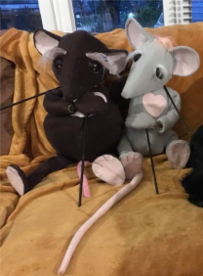

YOUR NEW COMMITTEE
Following the AGM in October the current committee is:
Chairman Bob Graham
Vice-chair Tori Wakeman
Treasurer Brian Gale
Secretary Maureen Higgins
Artistic Director Jen Eglinton
Theatre Stage Manager Keith Higgins
Membership Manager Hilary Thompson
Front of House Manager Joan Wakeman
Publicity Manager Anne Booth
Maintenance Manager Neil Chamberlain
Technical Manger TBC
Props Manager TBC
Box Office Manager Faye Bingham
Wardrobe Manager vacant
Committee members Katy Ball, Andy Bingham, Richard Casewell, Pat Gale, Hannah Tolley,
Not too many changes – we do welcome back on board Richard Casewell, Neil Chamberlain, Jen Eglinton and Bob Graham at the helm as our new Chairman.
Many thanks to Stephen Downing , the outgoing chairman and Carol Wright who has relinquished her role as Wardrobe manager, which she had held for many years, although she will continue to work on shows and has a great team around her. If anybody feels able to step up and take on responsibility for this vital side to our shows please see Bob!
Thank you to Neil for stepping up as Maintenance manager. The office are proposing to hold a ‘Maintenance Diary’ for any requests/reports for Neil. Emergency reports should go to Gary and he will contact Neil or decide on action.

PUBLICITY REPORT
We have been reaching out to many new audiences this year via our links with the Kidderminster Heritage Opportunity Group and our Suffragette Day in September followed by the Armistice Tea afternoon in November were very well received. We received good coverage in the Kidderminster Shuttle both in print and on-line.
FACEBOOK – thank you to those members who regularly share the posts that appear on our page. It is a great way to spread the word! Our page is administered by Jen Eglinton, Tori Wakeman, Natalie Bayliss from the office and me. We have our own closed group page for The Nonentities to share messages, pleas for assistance, good news etc. New members- make sure you are on it if you’re a FB user (contact me for info) Can current members check their notifications for this site and make sure you have it open to all posts – other wise you might miss something!
THE BROCHURE for our Spring/Summer season is ready to go and I invite you all to our STUFFING DAY on Monday January 7th. This is where we gather round tables and stuff brochures and fliers into envelopes ready for labelling and posting to about 3,000 customers. So, lots of workers are required and there is chance to chat and socialise – coffee and biscuits keep you going and sandwiches and cake at the end! We usually start at 10am and hope to be all done by 12. New members are particularly welcome
Anne Booth annebooth71@gmail.com 07891952593
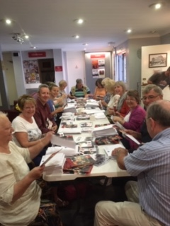
MEMBERSHIP MATTERS
A warm hello to all members new and old. At the AGM I agreed to be the Membership Manager for another year. It's a job I enjoy so no problem there. Please do feel free to get in touch if you have worries or queries, or even news. I see this as a job to support all members not just to recruit new. All queries about FOH duties should go to Joan Wakeman, our FOH Manager.
This year we have been particularly blessed with new members who have stepped in and worked hard on FOH as well as planning to get involved in shows coming up. Sally Howes did a sterling job painting on the Witches set, Steve Bougard is hoping to act, Wendy Myers is assisting with props for “Earnest” and Jane Holt has become a FOH stalwart. Debbie Newbould and Alan Booth joined us as part of the Suffragette day and we hope to see more of them! A particular mention for Janet Poole who joined at the beginning of the year. She has made brilliant props on request, painted sets and been a real asset on FOH – not least 4 nights for Witches.
All members are encouraged to take on backstage roles – ASM, Props, Prompt, Wardrobe. We have had some gaps recently but going forward looks better. Backstage is so crucial to a production and we will be running workshops in the New Year, and it is fun. All the fun of the play but no lines to learn!
After some further discussion on the proposed Membership Subs the Committee has made a final decision about the rates and you will see these below. This will apply from 1.1.19 so get in quick if your membership has run out!!.
We are hoping to split the Membership Manager role now with having a Social Secretary – members nights, annual events etc. Offers to support and assist would be welcome.
So have a good festivity and see you all in the New Year
Hilary Membership Manager 07500337585
Amended Proposals Agreed by Committee 4.12,18
At the Committee Meeting on 25th September 2018 it was agreed that Membership Subscriptions would increase and/or be amended from 1.12.18. The proposed amendments were notified to members and following feedback further revisions Have been agreed as follows, for implementation from Full details are on an email all members will have received 1.1.2019:
Type Current Proposed New
Full £45 £55
Full Concession (1) £25 £35 Senior 65+
Full Concession (2) £25 £30 Student and unemployed
Associate £10 £15
Joint Full £95
Joint Senior Concession £60
Joint Student u/e Concession £50
Joint Associate £25
As from 1.1.19 the definition of pension age concession will be changed for all members, new and existing to age 65 (previously 60)
The criteria for a Joint Membership is for 2 members living together and sharing housing costs.
Please note we have agreed for the first time to split the concession rate between senior (65+) and Student/unemployed. Although it would be helpful to members to bring in phased payments this presents significant difficulties for bank reconciliation purposes for the Treasurer at present. During the course of the year systems will be explored whereby this might become more of a possibility.
It should be noted that members are regularly reminded to check their status and that acting and backstage activity most certainly, cannot be sanctioned if people have not paid. Special circumstances can always be discussed in private with the Membership Manager.
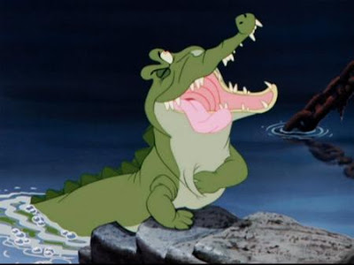
Stage manager’s view
Hilary Thompson

I was privileged to stage manage the KRYPT production of Peter Pan. They played to 2 full houses and 40 parents at the dress rehearsal. It was a great production written and led by Becca Williams our Youth Leader and supported by Jess Schneider and Andy Bingham her two Assistants. They in turn were supported by Beth Dalton and Thom Powell (ex KRYPT members) through rehearsals. The dance, “flying” and battle choreography were very professional and from my point of view safe – that's a lot of swords, sticks and arrows!!
In the short time to turn it round from off stage rehearsal to staging I was really grateful to a brilliant backstage crew. Andy B produced atmospheric lighting and super sounds – especially enjoyed the battle scene music! Thom P assisted Andy and is learning the technical ropes. Silhouettes were used, learned from our puppetry from Witches. Costume as ever ably done by Lynn Ravenhill – lots of changes, with Kate Williams (Becca's sister) making amazing mermaid tails and Tinkerbell wings. We even had a painted wooden leg! The actors all looked superb – good hook! Alison Carr, a parent did hair – quite amusing as she had to do a lot of “untidying”.
Well – what can I say about props – Anna Murphy played a blinder yet again, with a child propelled crocodile, bedrooms, jungles and so much more. Sally Howes, a new member assisted Anna which was great. The set was an adaptation of the Witches set - done by Keith H, Mike L, Colin T, Anna M and Nick Haynes. It worked so well – from Hotel Majestic to the “Jolly Roger”. Thanks to Jen Eglinton for designing something that could be adapted so readily. I even survived my incipient heart failure with children up on the lower rostra.
On the two days Jack Brooke (Becca's partner) was on very chilly guard/chaperone duty downstairs with Lynn, with Jess and Beth D martialling New Boys and Pirates and Toxicus warriors as well as set changing! Beth was even seen briefly as a pirate – good to have one of the crew on stage during the fights. In the wings we had Kate and Jane Williams helping to set change. My particular thanks to Stephen and Sue Downing for their stalwart 2 days of set changing (at least 7 set changes per show), especially without Anna on the Sunday.
The children acted well, lovely characterisation, had learned their lines, took responsibility for their props and safety and were on and off set promptly. Well – what more can I say – a really successful production. With FOH and bar on full duty for a show which ran as per a senior show with an interval, the audience were entertained and we made good sales. Great to have significant numbers of non parent audience applauding the young people's work. They're getting used to it.
I thoroughly enjoyed myself, despite the responsibility - children and animals? – well we did have a dog, some mermaids and a crocodile!! Well done to all. I think I'll have a lie down now.
Hilary - Stage Manager
NEWS FROM KRYPT
Four months of hard work came to head this weekend as the entire Youth Theatre pulled together to present Peter Pan.
As the curtains opened, the audience were treated to a visual feast: a stunning set complimented by an array of colourful costumes and clever props.
We had three fairytale-style children’s beds in front of a huge window; an adorable wooden crocodile just the right size for a small child to lie in and drive; a ship complete with mast, rigging and wheel; a silhouetted city-scape of London; and four puppets of the children sailing through the night sky to the second star on the left. The members wore Victorian party outfits which contrasted with leafy, muddy and ripped Lost Boys; an elaborate Captain Hook wig complete with a hand-made hook; and four stunning mermaid tails, not to mention Tinkerbell’s gleaming gothic wings.
Watching proudly from the wings and the tech box during each performance, we were all blown away by our members’ performances. Hook had comedic and jeering banter with the audience; Michael flew in the hands of graceful shadows; Tootles stood proudly on an otherwise-empty stage to deliver her first monologue at the grand age of 8 years old; and Tinkerbell and Peter had the audience reduced to tears in that scene.
The entire cast acted like a troupe of professionals. They remembered their lines, projected their voices, and adapted to on-the-night issues like a forgotten biscuit or misplaced piece of rope. The audience were really impressed by the interpretations and deliveries of each character, especially when so many of our young actors had two or three contrasting roles to portray. They also commented on the excellent choreography and delivery of the sword fight scenes, some of which the children had devised themselves and all of which they thoroughly enjoyed.
Hilary Thompson has written a stage manager’s view of the show elsewhere in this newsletter and I echo all the thanks she gave to my crew. The hard work of the last term was all worth it in the end and we were reminded that really, all it takes is faith, trust and pixie dust
Becca, Jess and Andy xx
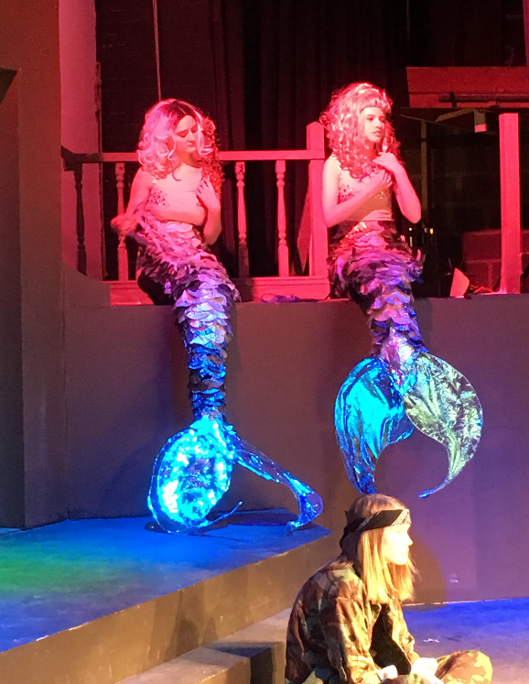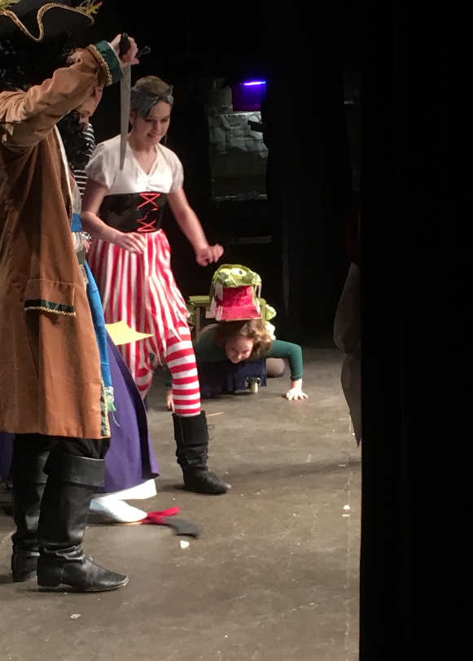

The Armistice Afternoon Tea & Entertainment Tuesday 6th November 2018 Kidderminster Town Hall

Following on from this year’s very successful and fun Suffragette Street Theatre project, the Rose Theatre’s “Concert Party” delivered an Entertainment for the Afternoon Tea, coordinated by the town’s voluntary Heritage Opportunities Group to mark the centenary of the WW1 Armistice.

It was great to have the support and enthusiasm again from Nonentities Members who volunteered to participate in a different kind of “theatre” and where we once again brought our skills to the Town Hall, the place where news of the Armistice had been broken to local people in November 1918.

With acute awareness of the very busy autumn period being undertaken by many of us involved in various other main stage and studio productions at the Rose, the need to carefully create interesting, appropriate and manageable content was upper most in my mind. With much coverage generally taking place elsewhere of the wider international issues of WW1, the different focus this year being on the Armistice marking the end of WW1, brought an opportunity to tell the story of how news of the signing of the Armistice had been received in Kidderminster. This seemed to be most appropriate and offer a unique contribution to local people. It required carefully balancing both the grim realities of what WW1 had meant, as well as through story telling, relate how it had affected local people, with some humour carefully added to the mix of celebration and commemoration.

I was fortunate in being given permission by local author Sally Dickson to draw from her excellent book on Kidderminster in WW1 in order to create a script to tell some of the stories. This, along with newspaper accounts which had recorded the actual spoken words of the Town’s Mayor, Aldermen and others, enabled me to weave a script together with WW1 poetry and songs, helping to create the mood and set the scenes. On the actual performance day, Stephen in playing the Mayor, had managed to persuade the current Town Mayor to lend him his chain of office (worth a fortune!) This was the very same item worn by the actual Mayor, Alderman Ray in November 1918, when he proclaimed the news of the Armistice and cessation of fighting to local people from the Town Halls steps and later, in a Service of Thanksgiving on the very same Town Hall stage!

With our very able cast including some members who had taken part in our recent Rose Theatre Studio Music Hall and Badge of Honour, Act 2 provided the opportunity to reprise some of the songs and monologues that would have cheered up audiences back in the 1918 era. The whole Entertainment was very well received by the audience between their tea and cake, and especially the Veterans attending from later wars. Some had had family members in active service in WW1 and I felt very humbled to hear that they thought our content “just right” and wished to pass their heart-felt thanks to everyone involved for such a splendid afternoon. A very busy time for us all, but another project & performance well accomplished and with a lot of fun and a chance for me to enjoy playing the Steinway Grand Piano! My grateful thanks to everyone involved, and for the Lighting and Sound design lead by Andrew Davie under trying circumstances due to the Town Hall equipment; Costumes coordinated by Lynn, stage management by Alan Booth and Brian Gale & FOH and general administrative elbow jogging to me by Anne Booth & Sue Clark! The pictures below were taken by Colin Hill.

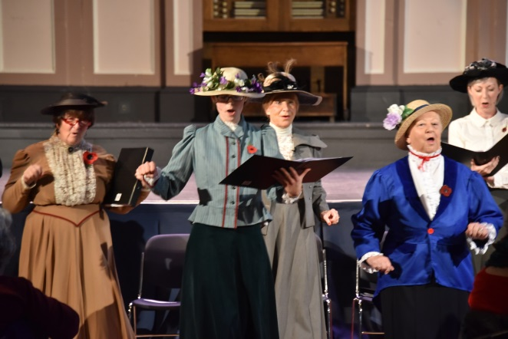
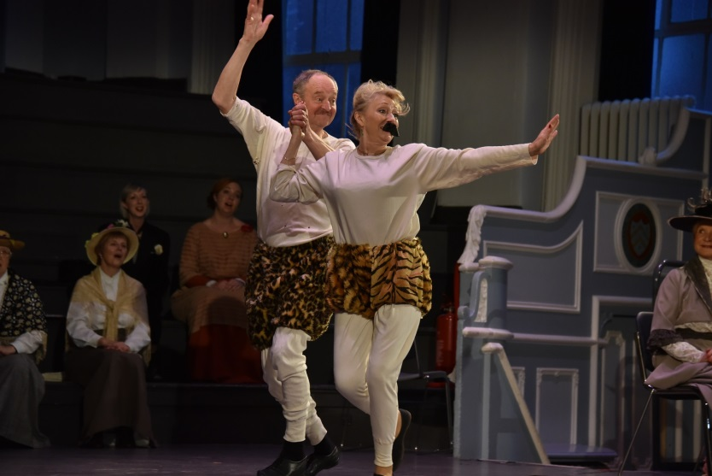
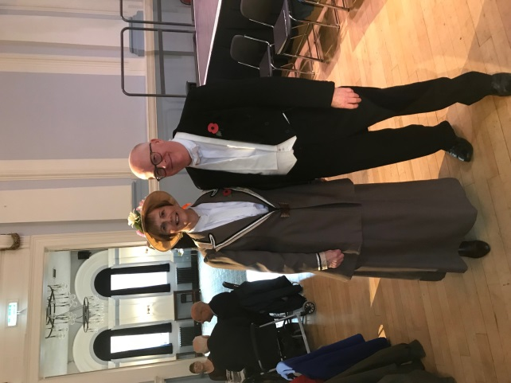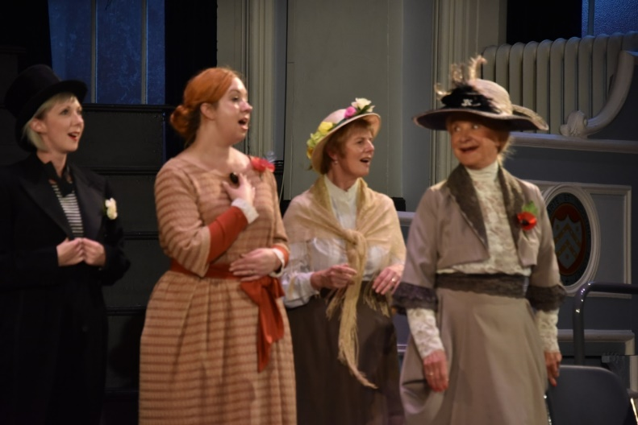

CASTINGS

The Kings Speech (25th Feb – 2nd March) – Director Tori Wakeman
First rehearsal – Monday 7th January 2019

King George V1 – Stuart Wishart
Lionel Logue – Richard Taylor
Queen Mother – Faye Bingham
Myrtle Logue – Katy Ball
Winston Churchill – David Wakeman
Wallis Simpson – to be announced
George V – Colin Young
Archbishop of Canterbury – to be announced
David (Edward VIII) – Stefan Austin
Stanley Baldwin - to be announced
Footman 1 – Chris Kay
Footman 2 – to be announced

Elsie and Norm’s Macbeth (8th – 13th April) – Director Sue Downing
First rehearsal - Monday 18th Feb

Elsie – Louise Fulwell
Norm – Tom Rees

Glorious (13th -18th May) – Director Richard Taylor
First rehearsal – Monday 25th March

St Clair – Patrick Bentley
Florence Foster Jenkins – Jen Eglinton
Maria – Hannah Tolley
Cosme McMoon – to be announced
Dorothy – Pamela Meredith
Mrs Verrinder-George – to be announced

The Vicar of Dibley (17th – 22nd June) – Director David Wakeman
First rehearsal – Monday 29th April

Geraldine – Tori Wakeman
David Horton – Bob Graham
Hugo Horton – Stefan Austin
Alice Tinker – Jess Schneider
Owen Newitt – Martin Salter
Frank Pickles – Stuart Woodroffe
Letitia Cropley – Pat Gale
Jim Trott – Steve Bougourd
Lady at wedding – Hilary Thompson

The technical teams for all of these plays will be announced as soon as possible in the New Year.

